Laboratory of Medical Zoology (LMZ)
NEON Tick Taxonomy ID SOP
Version: 1.0
Effective date: 10/30/2024; Final approval date: 3/10/2025

Receipt and Custody of Specimens
Once samples are collected from the field, NEON field ecologists process, pack up and ship the samples to LMZ. Ticks sent by US Mail arrive on weekdays in the morning. Ticks sent by courier (UPS or FedEx) may arrive throughout the business day.
Incoming ticks:
- Ticks submitted by NEON will come by the NEON domains. Each domain ships every 1-2 months based on their capture rates. Upon shipment, a Chain of Custody email is created which contains both a manifest and a receipt file. Open the container(s) and ensure all samples listed on the manifest have been received and are in good condition (e.g., not broken or missing; labels are legible). Notify NEON of any shipment issues by replying all to the Chain of Custody email associated with the shipment.
- The electronic receipt form included in the NEON shipping email must also be completed to document the condition of samples upon receipt. Each completed receipt form will be uploaded to the NEON Data Portal per instructions provided by NEON.
- NEON tick vials contain 95% ethanol and labeled with a barcode and sampleID. After reconciling with NEON manifest, ticks are then moved to identification room at room temperature for Identification.

Processing and Identifying Samples
- NEON ticks from each domain should contain sampleID numbers in each vial. For example: STEI_001.20230704.
- A trained technician/Entomologist should carefully remove all ticks from the bag/container containing unique sampleID number into a petri dish/weight boat.
- Place the petri dish/weight boat with the ticks from same sampleID under a microscope and identify the species and life stage (Larva, Nymph, Adult Female, and Adult Male) using referenced (See list at the end of this document) Identification key. Sort and count each tick species by life stage. Larval specimens should be enumerated but not identified to species; instead, all larvae should be noted with the scientificName ‘Ixodidae sp.’
- If individual ticks cannot be identified to species by Contractor, the genus or lowest taxonomic rank should be reported, as well as the reason for the failure to identify to species (e.g., damage, taxonomic difficulty). This information should be reported in the ‘remarks’ field of the datasheet (2c). These cases should use the format of ‘Lowest taxonomic rank sp.’ (e.g., Amblyomma sp.) for individuals for the scientific name field.
- Create a subsampleID based on every life gender/stage/species combination and enter the subsampleID into the NEON datasheet in the format: sampleID.taxonID.sexOrAge (ex: STEI_001.20230704.IXOSP.N) and counts.
- To prepare samples for pathogen testing subsampling and subsequent shipment to NEON Archive facility, transfer all ticks from a subsampleID into a 20 mL scintillation glass vial (Fisher Scientific Catalog No. 03-337-7) with >22mm poly cone seal screw cap filled with 95% ethanol.
- Each 20 mL scintillation glass vial should be labeled with a Quick Response (QR) barcode with human readable component for the barcode (subsampleCode, format: QK00000000001). The label should be oriented lengthwise on the vial.
- Each vial should also contain an internal label with the subsample ID corresponding to the subsample code. The internal label should be printed on archival paper with alcohol-insoluble ink and should be generally visible from outside the vial, as much as possible.
- Record all required identification information (NEON format: 2c_Tck_TaxID_DataIngest) for each sample in a spreadsheet (UMass online shared OneDrive).

QAQC, Data Return and Sample archiving
1. Once all ticks are counted and identified, the quality assurance of tick identification will be checked on a yearly basis:
A) Randomly select 3% of the total tick samples.
B) Verify that subsamples are accurately enumerated, and subsamples have accurate identifications. QA data shall be returned to Battelle along with standard datasheets.
Discrepancies are recorded (if any) and the following equations are used to evaluate quality of work.
Equation 1, Percent Difference in Enumeration (PDE):
𝑃𝐷𝐸 = (|𝐶𝑜𝑢𝑛𝑡1−𝐶𝑜𝑢𝑛𝑡2|/|𝐶𝑜𝑢𝑛𝑡1+𝐶𝑜𝑢𝑛𝑡2|) 𝑥 100
Equation 2, Percent Taxonomic Disagreement (PTD):
𝑃𝑇𝐷 = (1 – (𝑎𝑔𝑟𝑒𝑒𝑚𝑒𝑛𝑡𝑠/𝑁) 𝑥 100
Where: agreements is the number of consistent identifications (species and sex match; if species and sex are identical, but identification qualifier differs, that is still considered an agreement); N is the total number of individuals in the larger of the two counts
2. Record QA results (NEON format: 2d 2d_Tck_TaxQA_DataIngest) for each sample in a spreadsheet (UMass online shared OneDrive).
3. Upload identification information (NEON format: 2c) and QA results to the NEON data portal within the required timeframe.
4. After pathogen subsampling has occurred, the prepared vials will be used for archiving and shipping.
5. Prepare an archive datasheet (NEON, 2e) and a shipping inventory (NEON, 2f) in NEON specified format). NEON will provide a prefix for the lab. Barcode labels must have a prefix + 11 numbers, Example barcode: QK00000012345. Print a 2D quick-response (QR) Barcode label with a Human Readable Component.
5. Cryo-Labels and Printers Approved for use by the NEON Biorepository at ASU: Brady Printer Ribbon: Brady IP-R6406, VWR# 490006-116; Brady Printer Label: Brady THT-59-492-10, VWR # 89077-356. Print barcode labels with corresponding subsampleCode using Brady printer and a subset of (10) these labels will be test-scanned with a barcode app.
6. Upload archive information (NEON: 2e) to NEON data portal.

Packaging and Shipping:
- Notify receivers (NEON and Biorepository): 1) the manifest, 2) the shipment date and 3) tracking# prior to shipping.
- The completed receipt form will be uploaded to the NEON Data Portal by the receiving lab.
- UMass use eShipGlobal's Shipping System: https://umassehs.eshipglobal.com/
Note: Steps 1 and 2 are to be completed before the day of shipping. Do not select to ship on a day where shipping delays are expected (see step 9). When selecting a day to ship, make sure the package is prepared and dropped off at a FedEx location by 2PM. If this is not possible, select a new day to ship.
- Notify NEON and ASU Biorepository several days ahead for the coming shipment.
- NEON will provide a lab-to-lab shipment form that will serve as the COC and need to be uploaded to the portal.
- All NEON archived ticks will be shipped at ambient temperature. Package the vials/contents inside a container and secure the contents with packing materials.
- Cover the container, place it in the cardboard box, and weigh it.
- Fill out the biological shipment required label (for example: UN 1845 label) using eShipGlobal shipping system, using the shipping information as well as the weight of the package converted to kilograms.
- Create the FedEx shipping label.
- Send 1) the manifest, 2) the shipment date and 3) tracking# and the expected arrival time to receivers (NEON and ASU Biorepository).
- Only ship out temperature sensitive packages on Monday to Wednesday using priority overnight mail to make sure that the package will be received on the next business day.
- Drop the package off at the FedEx location by 2 PM. Keep the receipt of the package.

- Upload shipping information (NEON: 2f) to NEON data portal.

Key to the stages and sexes of Family Ixodidae
Laboratory of Medical Zoology, September,2017

1a. Three pairs of legs, spiracles absent……………………………………………………….…..Larva
1b. Four pairs of legs, spiracles present…………………………………………………………………..2

2a. Scutum covers entire dorsum of the body (idiosoma)…………………………Adult Male
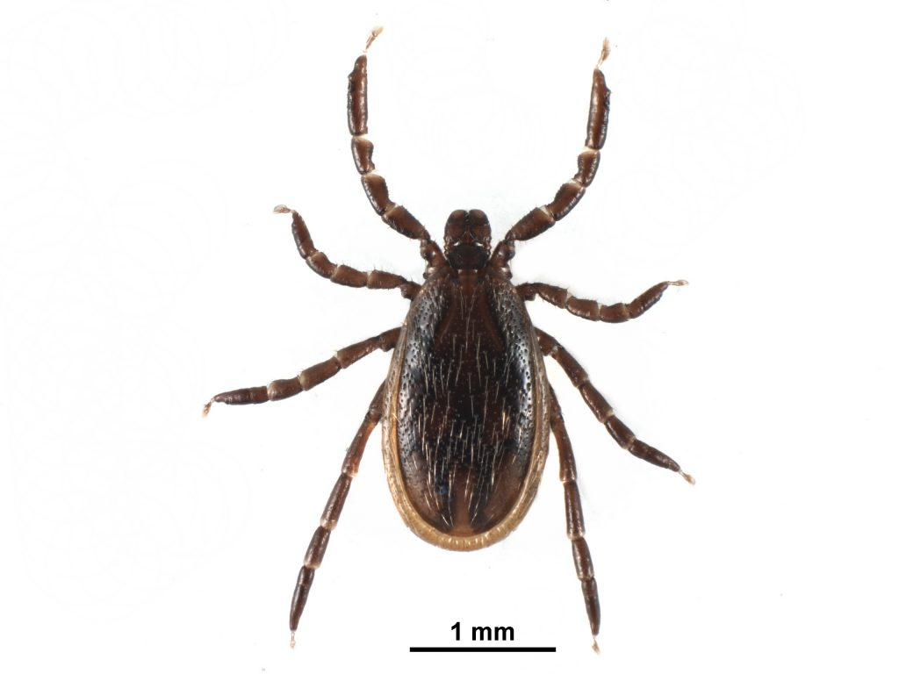

2b. Scutum confined to anterior of anterior of dorsum………………………………………………3
3a. Genital opening and porose areas absent………………………………………………….Nymph

3b. Genital opening and porose areas present…………………………………………Adult Female

Appendix:

Basic Knowledge of Tick Identification
- When identifying ticks: Don't go by size and Don't go by color. What to do:
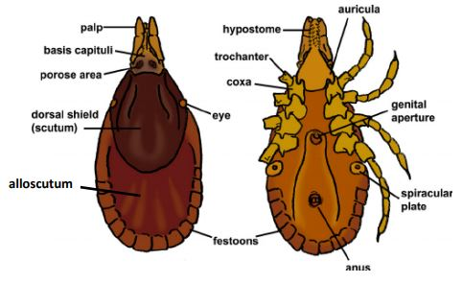
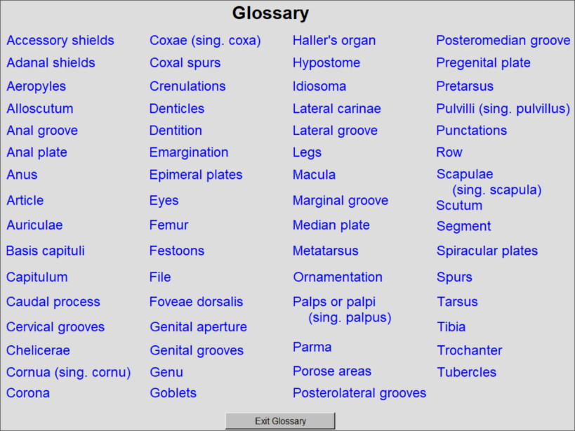
- 1 )Do learn the basic tick body parts that are useful for ID. Understand the following glossary from the Armed Forces Pest Management Board’s “interactive program for teaching tick morphology” CD.
Fig. Diagnostic characters of hard ticks.
- 2) Do determine Family and Genus of ticks. Do determine life stage (Larva and Nymph) and, for adults, whether male or female (some characters used for ID are not present in all life stages). Using above “Key to the stages and sexes of Family Ixodidae”.
- 3) Do look at key characters: Scutum, Anal Roove, length of the Palps relative to the Basis Capituli and the shape of the Basis Capituli and whether it extends laterally. Learn these characters and identify the four tick species from the Armed Forces Pest Management Board’s “interactive program for teaching tick morphology” CD.
- 4) Do understand and use the identification key (see below reference and more in tick morphology” CD).

Reference:
Keirans JE, Litwak TR. Pictorial key to the adults of hard ticks, family Ixodidae (Ixodida: Ixodoidea), east of the Mississippi River. J Med Entomol. 1989; Sep;26(5):435-48.
Cooley RA, Kohls GM. The Genus Amblyomma (Ixodidae) in the United States. J Parasitol. 1944; 30:77–111.
Keirans JE, Durden LA. Illustrated key to nymphs of the tick genus Amblyomma (Acari: Ixodidae) found in the United States. J Med Entomol. 1998 Jul;35(4):489-95.
Brinton EP, Beck DE, Allred DM. Identification of the adults, nymphs, and larvae of ticks of the genus Dermacentor Koch (Ixodidae) in the western United States. Brigham Young Univ Sci Bull. 1965; 5:1–44.
Durden, LA, Keirans JE. Nymphs of the genus Ixodes (Acari: Ixodidae) of the United States: taxonomy, identification key, distribution, hosts, and medical/veterinary importance. Thomas Say Foundation Monographs.1996
Keirans JE, Clifford CM. The genus Ixodes in the United States: a scanning electron microscope study and key to the adults. J Med Entomol Suppl. 1978 Jul 20;2:1-149.
Schultz, G. W., Robbins, R. G., and Hill, D. W. (2005) Interactive Program for Teaching Tick Morphology. Version 1, CD ROM. Defense Pest Management Information Analysis Center, Armed Forces Pest Management Board, Walter Reed Army Medical Center, Washington, DC.

